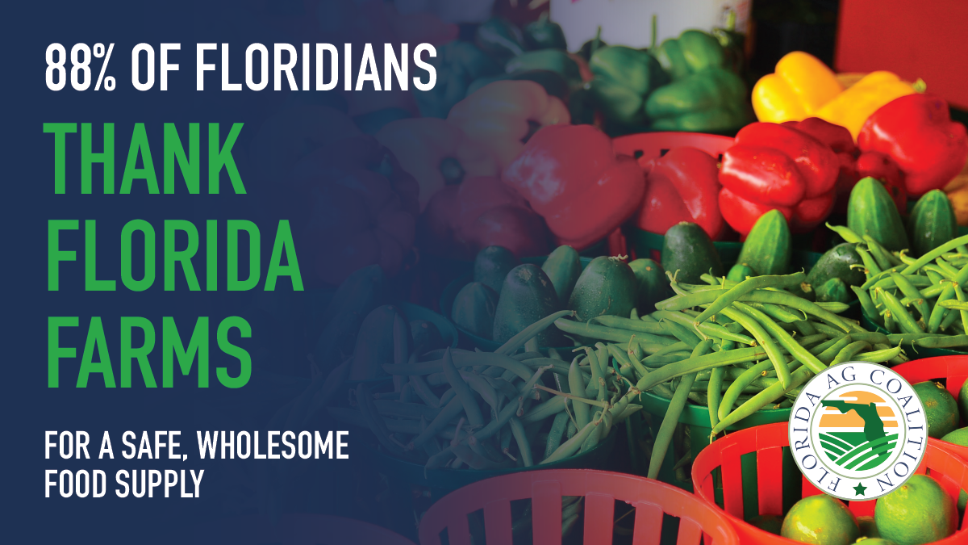

Floridians know that Florida farmers work hard every day to produce safe, wholesome food for our families and those across the nation.

