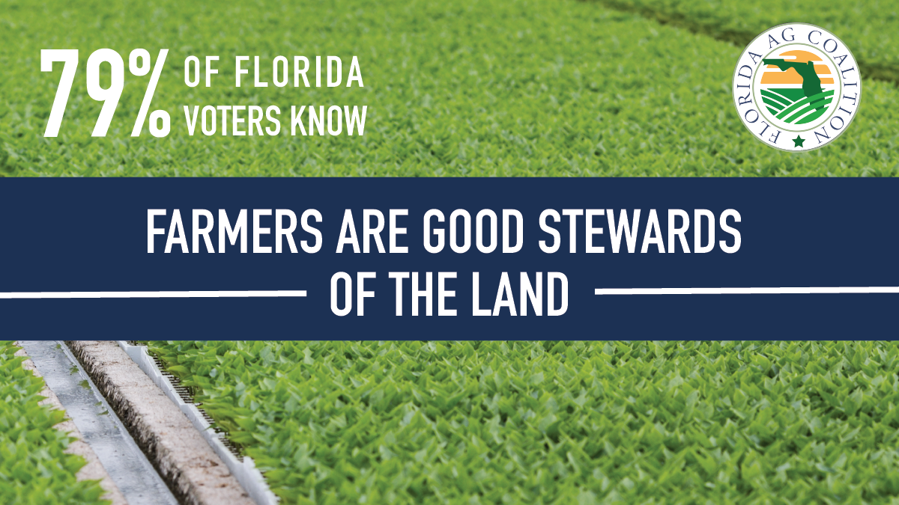

We are proud of the support of our fellow Florida residents. Every day, our farmers, growers and ranchers work long hours to ensure you receive fresh products to help feed your families.

