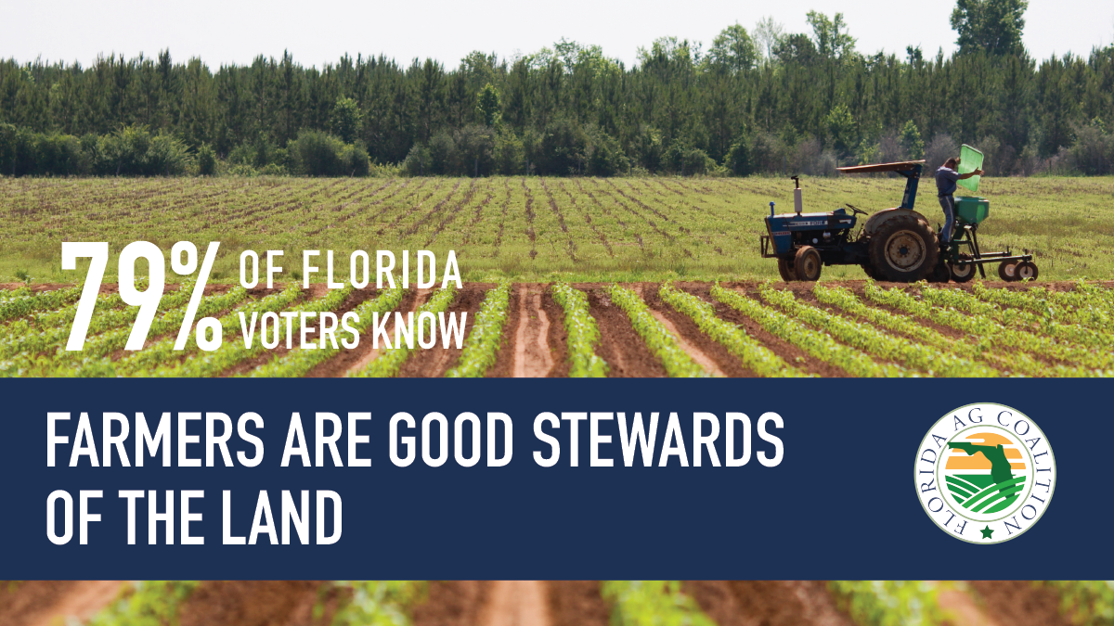

Floridians know farmers care for more than just the food that nourishes others. They care for the land and environment that provides this wholesome food. That’s why our Florida farmers are doing all they can to preserve and protect Florida’s natural landscape for the future.

